# Pets

You need to add 20 things to this document. (Make sure to number them just as I did in the example.) It may be helpful to copy and paste this list and then fill it in as you go along. All image names must start with your location, e.g yellowstone_sunset.jpg unless you are using a link from the internet.

## Smoothie

1. 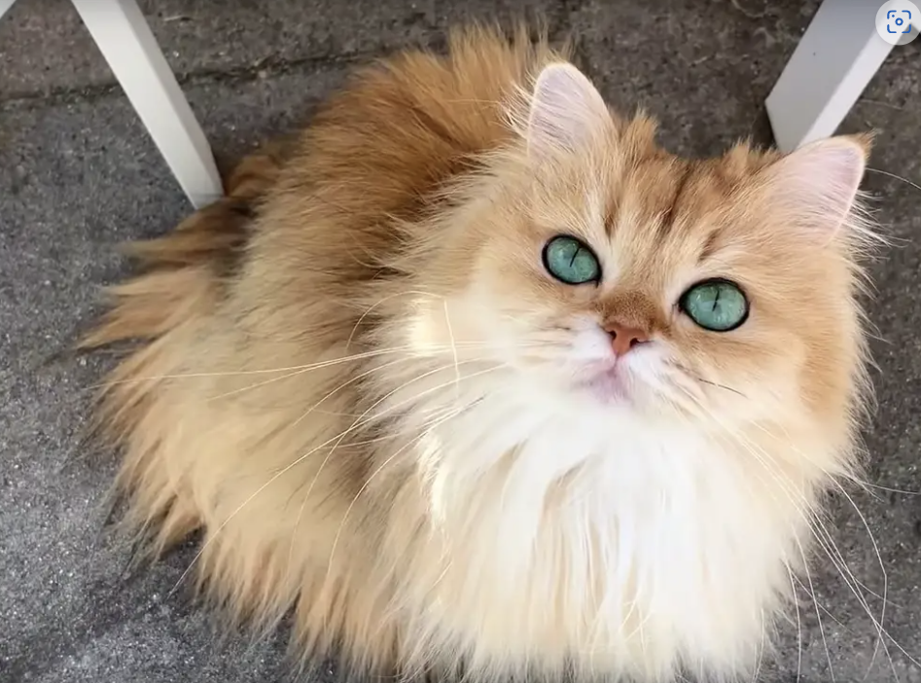
2. Smoothie_staring.jpg
3. Long-hair beautiful, orange tabby cat
4. Smoothie has been dubbed the "world's most photogenic cat", and her emerald eyes and golden fur have even inspired a mural in New Zealand. Smoothie also has an aptly-named brother named Milkshake, and the two are often featured together across social media platforms.
5. She became an internet sensation with 2.3 million followers on her smoothiethecat Instagram account.
6. **Photo Gallery**
7. Smoothie_yawn.jpg
8. Smoothie is yawing
9. Smoothie_lying.jpg
10. Smoothie is lying.
11. Smoothie_staring.jpg
12. Smoothie is staring at you
13. Smoothie_curious.jpg
14. Smoothie is curious about the world
15. **Likes**
16. playing
17. sunshine
18. Your Name

Fengyu Zhang + Siqing Xu + Boyuan Ma

## Bacon Q Dog



1. bacon.jpg
2. Brown labradoodle wearing colorful lei
3. Bacon Q. Dog is a 9yr old labradoodle. He prefers to spend his days lounging among the three different beds/couches that his family has gifted him. He enjoys a walk or two around the neighborhood, as long as he can pretend that he doesn't see any of the other animals to avoid the embarrassment of not wanting to admit he has no wolf-like skills in chasing them.
4. At night just as the rest of the family is ready to relax, Bacon suddenly wants to release all of his energy. He will place his toys on a mini couch and frantically drag the couch around, giving his toys "a ride." There is also a lot of rolling. Lots and lots of rolling.
5. **Photo Gallery**
6. bacon_bandana.JPG
7. Brown labradoodle wearing an orange bandana
8. bacon_graduation.JPG
9. Small labradoodle puppy wearing a graduation cap and gown.
10. bacon_agility.mov
11. Girl and dog demonstrating a sit and stay procedure
12. bacon_halloween.JPG
13. Brown labradoodle wearing a pirate costume
14. **Likes**
15. Belly rubs
16. Playing tug-of-war
17. Sneaking onto the couch
18. Colleen van Lent

## Fitz

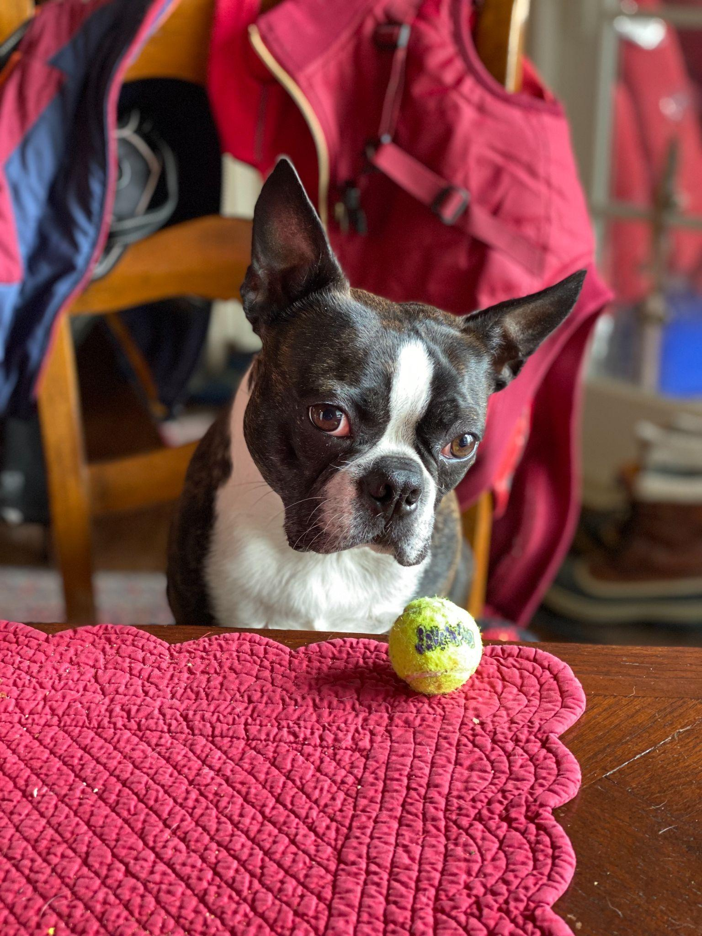

1. Fitz.jpeg
2. Boston terrier watching a tennis ball at the table.
3. Loves chasings tennis balls, chipmunks, squirrels, and birds. Often found sitting by the fire in wintertime, and in sun patches when available. He’s energetic, mischievous, and easily bored. He loves people and gets grumpy if left without a lap too long.
4. Loves barking up trees, running around on the lawn, and digging in the dirt looking for moles. He especially likes getting treats and whines when he comes inside and doesn’t get a snack.
5. **Photo Gallery – (Just write Photo Gallery)**
6. Fitz_standing_on_chair.jpeg
7. Fitz standing on a wooden chair, looking at the camera.
8. Fitz_sleeping.jpeg
9. Fitz sleeping in a fuzzy dog bed.
10. Fitz_on_the_lawn.jpeg
11. Fitz laying out on the lawn in the grass.
12. Fitz_laying_in_bed.jpeg
13. Fitz sleeping with his face buried in a plaid blanket, only his head is visible.
14. **Likes**
15. Blankets
16. Being warm
17. Barking
18. Kay Malan + Anna Vento